Requirements for Dynamic Channel Control of rx888 – DRAFT 2
June, 2025 – W. Engelke, AB4EJ

This document explains the requirements for a set of functions to enable science users to request selected rx888 stations to add a channel to their suite of frequency ranges being monitored. This is called a Channel Configuration (CC). For ease of explanation, this document uses the term “rx888” to refer to the Software Defined Receivers (SDR) in observer stations, but additional SDR types may be added.

Objectives & Rough Requirements
“Science Users” means those PSWS accounts that have the privileges to be able to create CCs. The screens & functionality to do this will be visible only to these users.
Science users should be able to do the following:
- See a list of rx888 stations that are available for CC
- Select the stations they wish to send a CC to; the selection method should allow filtering available stations according to a geofence or other criteria such as remaining capacity
- See which stations have accepted a CC
- Filter observations to see those which have been created by their own CC or the CC of another science user
- Download observation data from their own CC or another CC using the Observations tab (same as downloading any observation)
- See capabilities and resources available at each station (i.e. CPU load, etc.)
Science Superusers should be able to:
- Cancel all pending and running CCs, or any arbitrary CC
- Initiate a CC to go to all available stations
Station users should be able to:
- See a list of CCs assigned to their station
- Stations provided by the project are to be controlled centrally; stations funded by volunteer can opt to accept or ignore CC requests or deletions

Discussion Question | Current direction
Do we need to make CCs expiring? (Science users will have the option to make a CC permanent or expiring. | Science users will have the option to make a CC permanent or expiring.
Do we need to limit the number of CCs in some ways (to avoid overload)? | Handle this on a station-by-station basis; prevent users from creating duplicate identical channels
How to manage the total bandwidth being monitored (total bandwidth could lead to overload of a user’s internet capacity and generate significant personal expenses)? | Does the project have the legal ability to reimburse a station owner for ISP fees generated by high data upload usage?
Should there be a maximum bandwidth? Is the sample rate fixed or programmable? (These two are related) | ? Maybe we need an algorithm that estimates how close we are to system limits in several areas such as amount of data being collected, potential internet capacity usage (as well as CPU and I/O capacity)
Does user get to specify format of the output (CCF vs raw A/D samples) (probably not) | This will be fixed as DRF
Can multiple CCs be assigned to a given station at the same time? How many? | Currently thought to be unlimited.
Observations List: should observations resulting from a CC be shown in the OBS list seen by everybody(probably) | yes
Should a user be able to cancel a CC assigned to their station by a Science User? | If station is a volunteer, yes; if station was provided by the project, no
Can a science user cancel a CC created by another science user? (Science Superuser can) | Probably not (?)
Should there be a science super-user with ability to cancel any and all CCs? | yes
How often do the stations send heartbeat? Every 10 minutes? | Try this at one minute intervals and see how this affects system components
Do we need a function to push a CC to every available station? | yes

Additional Open Points
Should there be some facility for automatically generating new channels in response to some detected phenomena, i.e., monitoring of solar flux or some other parameter?
Should volunteer stations be allowed to add channels to their own station (even if not a science user) ? | They should be able to record the data locally, but not necessarily upload it to the UA server unless approved.

User Interfaces / User Stories
This section shows some scenarios of what user experiences could be to stimulate brainstorming for how this system could work. The discussion below is not to be construed as a functional specification (that will be a separate document that will be based on what is approved for implementation, and may differ significantly from the following).
Meteor Scatter QSO Party
We may want to define IQ channels on the 10 and 6 m meteor scatter channels only on specific days to support the Meteor Scatter QSO Party.
WWV/WWVH Scientific Modulation Test
We may want to record full-bandwidth WWV/WWVH at 8 and 48 minutes after each hour to capture the HamSCI scientific modulation test.
HAARP Campaign Support
We want to be able to schedule specific stations to operate in conjunction with HAARP campaigns as they are announced.
High Kp / Trigger Modes
We may want to increase bandwidth on certain channels, or add channels when certain space weather conditions are triggered. For instance, if there is a geomagnetic storm and Kp goes high.
Science User Experience
Start of process
PSWS displays a map of stations, that can be filtered to show stations based on type and status (active, possibly active, inactive, retired, etc.); if logged-in user is a science user, they will have one or more additional filters such as:
- Stations available for CC
- Stations with currently active CC to the user
- Stations with currently active CC to any user
- Station location in both geographic and geomagnetic coordinates
- Station capabilities (i.e. frequency capability).
- Station load (Including the ability to view the stations in order of current work load)
The map will, upon activation of this filter, show just those stations meeting the filter criteria.
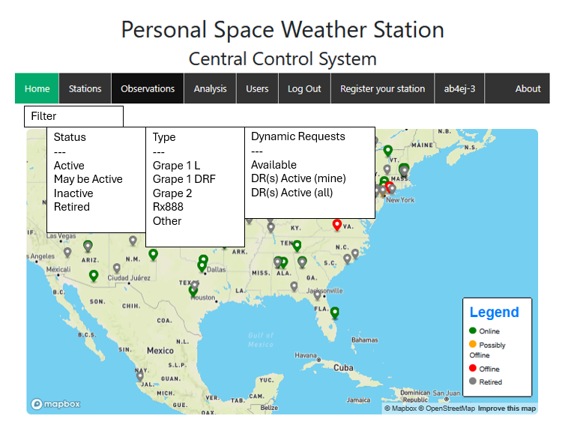
A secondary display shows a list of stations that support CC (possibly this can be combined with the CC assignment function):
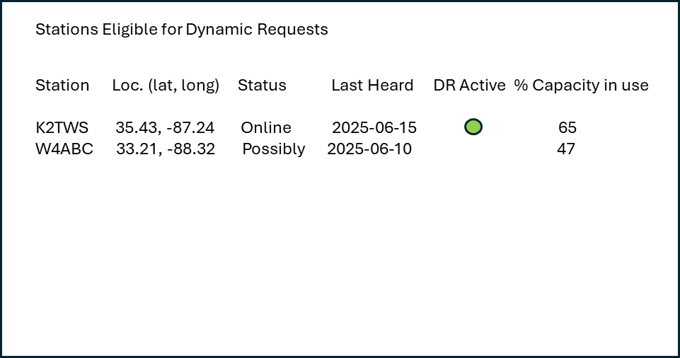
In the display above, the overall data collection capacity in use is shown. This display is sortable by any column, so users can list stations in order of ascending or descending capacity in use. Also, users can display by capacity remaining.

Assigning a CC
When a Science User wishes to create a CC, it should be possible to select a single station, a group of stations (by individual selection), or a group of stations by geofence (either by geographic or geomagnetic coordinates). In the case of a geofence, the science user should be able to draw a rectangle around desired stations on the map of active stations and the geofence is created based on that (all stations that fall within a rectangle bounded where the northwest and southeast corners are specified. If the area to be covered is not rectangular, the user can make multiple requests (these will show up as separate CCs).
Working with individual stations
- Show a list of eligible stations

Click on a Station for Dynamic Request
Station Loc. (lat, long) Status Last Heard CC Active
K2TWS 35.43, -87.24 Online 2025-06-15
W4ABC 33.21, -88.32 Possibly Online 2025-06-10
- Edit. Station names (underlined) are links. Clicking on a link takes user to a screen like this:
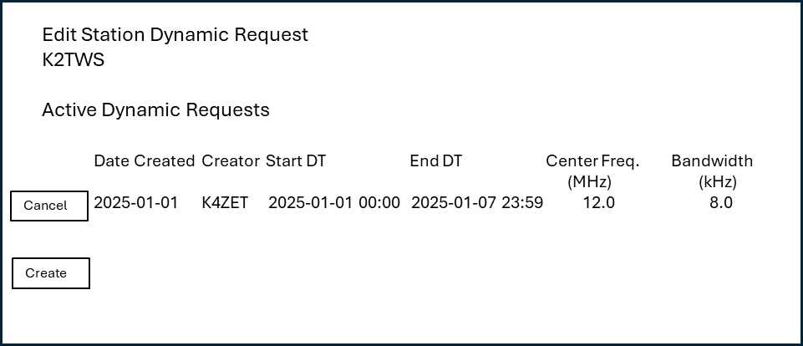
The screen shows any active CCs, with the option to cancel (kill) active ones. (This may be limited to the science user who created them, with science superuser able to kill any request.) Canceled requests will instruct the station to halt that data collection upon next check-in (heartbeat) and upload what has been collected so far.
- Create. To create a new CC, click the Create button, and get a screen like this:

The system will check for valid datetime (YYYY-mm-dd HH:MM), verify the datetime is in the future and End DT is greater than Start DT. System will check that Center frequency is one the instrument can achieve; similarly with Bandwidth.
Create Station Dynamic Request
K2TWS
Start DT End DT Center Freq. (MHz) Bandwidth (kHz)
______________ _______________ ___________ _________
Create

Heartbeats
Stations that have ability to accept a CC will send a heartbeat to the PSWS at intervals. Processing these is the Heartbeat API
- If there is no new CC for this station, PSWS updates the Last Heard field in the station table (instrument table?)
- If there is a new CC for this station, PSWS sends a job package to the station as a reply to that station’s next heartbeat
- If there is a cancellation of an existing CC, PSWS sends a job cancel message to that station as a reply to that station’s next heartbeat
- Open: can a station refuse a CC or send an error response to PSWS? Does station send a “job accepted” message? (Will need to support a state machine if so)
Functionality at stations (rx888 or equivalent)
- Send heartbeat (https API) at a configurable interval
- Receive a response; if response is a CC package, start a new receive channel; if response is cancellation of running CC job, halt it and upload observation
- Upload new observation(s) for CC jobs in progress (daily)

Database
Probable database updates to support the functionality of CC
CC table, pointing to station; incl. start DT, stop DT, center freq., bandwidth.
Implement Science Superuser concept; Add field in auth_user to allow user to be a Science User; add functionality to admin package to allow for maintenance of Science Superusers
Auth_permissions already allows a set of permissions to be created that allows adding band, center frequency, etc.

Possible Process Diagram (swim lanes)

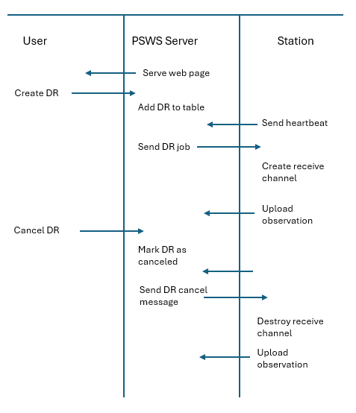

For geomagnetic coordinates, the system will use the Python AACGM library.

